This paper will convers details of the data warehouse designed and developed for the Department of Disaster Prevention and Mitigation (DDMP) in Phuket, Thailand to address disaster management. DDMP goal was to improve data quality so decision makers would be able to make better decisions to address the countries disaster management. A brief description of the four phases of disaster management, the conceptual model, methodology and data warehouse structure will be discussed.

Disaster Management cover four areas: preparedness, response, recovery and mitigation. In the preparedness phase, the agency aims to prevent disaster from occurring. In the response phase, the goal is to save lives and minimize losses. In the recovery phase, activities focus on helping the community to return to normality. Finally, in the mitigation phase, risk to life and property are mitigated. In all phases of disaster management, information is required for decision support. Data comes from both private and public sources such as emergency management, oceanic and atmospheric agencies, non-governmental organization, and social networks just to name a few.

One of the challenges the agency faced is that data is distributed in different heterogeneous data sources with multiple formats and cannot be easily combine. The agency had to solve how to integrate data from heterogeneous data sources to a data warehouse to increase real time data availability.

Figure 1 is the conceptual of Business Intelligence model for disaster management and Figure 2

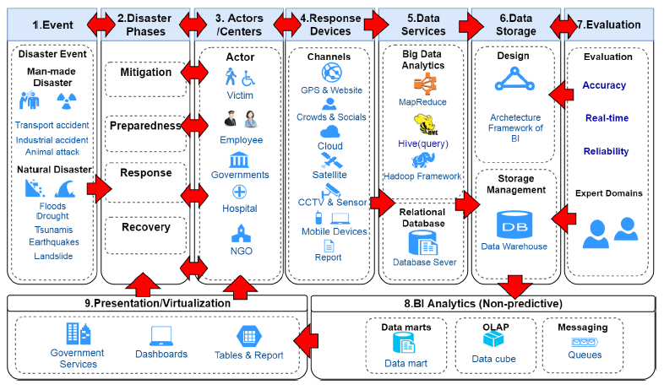

Figure 1 Conceptual Model of BI on disaster management

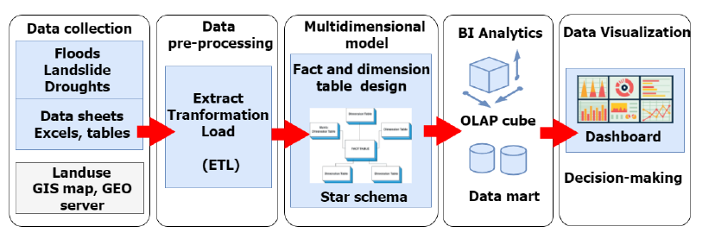

Figure 2 Methodology

In the collection phase, the focus is on the collection and integration of secondary data from DDPM. This data contained information on villages, sub districts, districts, population, households, time, geographical features, warning system, training, flood and landslide reports, and drought reports.

In the preprocessing phase, ETL process were applied using SQL Server and SQL Server Integration Services. One of the task performed was to convert the disaster subtype data from flat file to data warehouse dimension table.

Data warehouse contained seven-dimension tables for geographical features, Phuket location, time, flood types, water for agriculture, water for use, and water reserves. The information in the dimension table were stored in the Thai and English language. Additionally, there were two fact tables for flood and landslide and drought.

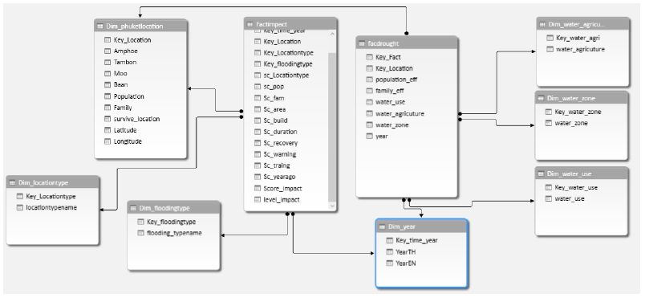

Figure 3 Dimension and Fact Tables

Phuket location dimension table has 10 attributes: dimension key, safety location, district, sub district, village number, village, latitude, longitude, population and number of households.

Time dimension table has 3 attributes: dimension key, year B.E. and year A.D.

Type of floods dimension table contains 2 attributes: dimension key and type of floods.

Geographical features dimension 2 attributes: dimension key and geographical features.

Water for consumption dimension table contains 2 attributes: dimension key and the sufficient quantity of water at the village level.

Water for agriculture dimension table contains dimension key and the sufficient quantity of water at the village level.

Drought fact table is used to compute the quantity of population and households which are affected by the drought. This fact table relates to the Water for Consumption, Water for Agriculture, Year, and Phuket location. The measure is quantity of population and households in village level.

Flood and Landslide fact table is used to compute the severity score in risk areas. Each area is an assigned a severity level based on the severity score. This fact table relates to Phuket location, Year, Type of Floods, and Water Zone.

Data Integration for disaster management is not an easy task due to complexity in disaster management life cycle which encompass heterogenous data sources from various in public and private sources. The Department of Disaster Prevention and Mitigation (DDMP) in Phuket, Thailand model for disaster management provides a practical implantation of data warehouse.